DESIGN ARTEFACTS DOCUMENT

FOR

Software for Dynamic Visualization of Cluster

Synchronization in large networks

CS-258

SUBMITTED BY: SUBMITTED TO:

Lalit Gautam Dr.Abhishek Srivastava

Varun Vinayak Joglekar

Sri Harsha Panugothu

Maharshi Sevak

1. Context Model



2. Structural Model

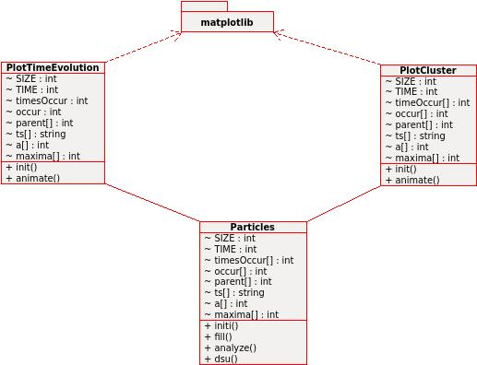

3. Interaction Model

3.1 Use Case Diagram

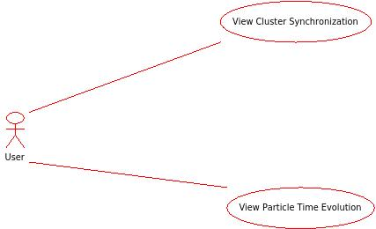

3.2 Sequence Diagram

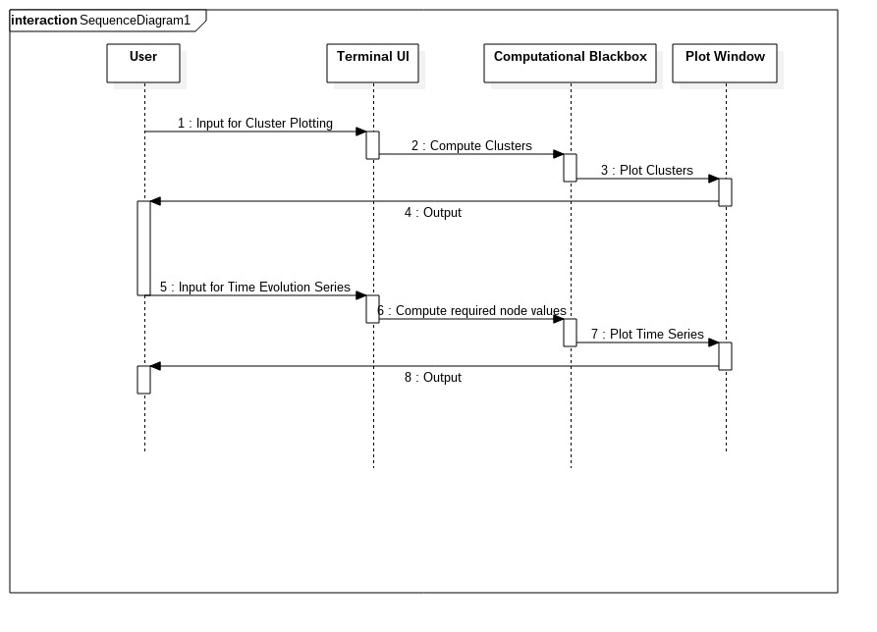

4. Behavioural Model

